|  |  |  |  |  |  |
| --- | --- | --- | --- | --- | --- |
| Unit 1  Mathematics Methods  Investigation # 3  Sequences  In-Class   |  |  | | --- | --- | | **Name** |  |   **Important Information:**  *Although the take-home component is not worth any marks, it is essential in preparation for the in-class component. Knowledge and skills gained will be extended in the in-class validation component. This in-class validation will be completed under test conditions on the day in which this take-home component is due. The take-home component may be used when completing the in-class component.* | | | |
| **Take home component weighting:** | *0% of the year* | **In-class component weighting:** | *5 % of the year.* |

***You may use your out of class section as notes for this test. CAS calculator permitted.***

**Part One: [7 marks]**

Jordie draws the following diagrams (L shapes) that are made up of rectangles. The first diagram shows a shape that uses three rectangles.

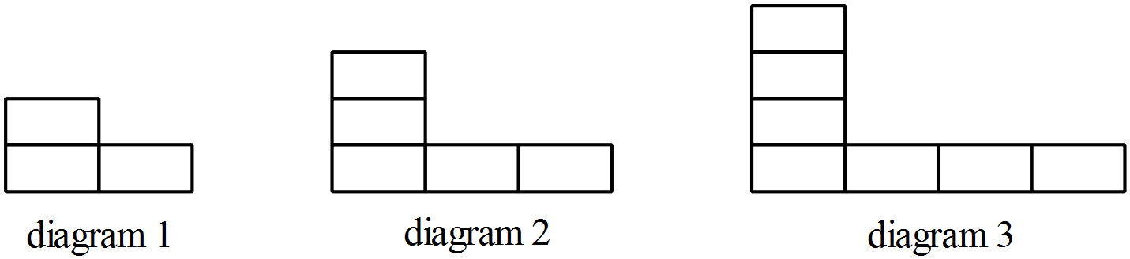

(a) Complete the table showing the number of rectangles needed for each shape.

|  |  |  |  |  |  |  |  |
| --- | --- | --- | --- | --- | --- | --- | --- |
| Diagram (n) | 1 | 2 | 3 | 4 | 5 | 6 |  |
| Rectangles (Ln) | 3 |  |  |  |  |  |  |

[1 mark]

successive

(b) Determine a ***recursive*** rule for the sequence of rectangles of the form

Ln+1 = ________________ , L1 = ____

[2 marks]

(c) Use the Recursive tab in ***Sequence*** and your rule from part b to determine L200

[1 mark]

(d) Determine an Explicit rule for the number of rectangles needed in Ln.

[1 mark]

(e) Which diagram number could you make if you had 200 rectangles? Show your method of solution.

[2 ma

**Part Two: [7 marks]**

Tamara draws the first five pentagonal numbers as shown in the diagrams below.

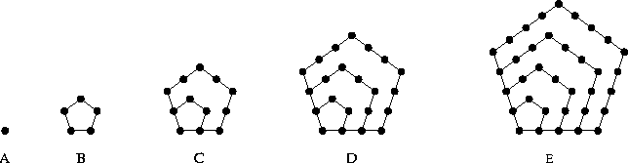

**1 5 12 22 35**

(a) What type of pattern do these numbers form?

[1 mark]

(b) Find a rule for the nth pentagonal number Pn. Indicate your method of solution.

[2 marks]

(c) Use your rule from part b to determine which pentagonal number could be made if you had 5 925 dots?

[2 marks]

(d) Complete the table below showing the rules for triangular, square and pentagonal numbers.

|  |  |
| --- | --- |
| **Type of number** | **nth term rule.** |
| Triangular number (*T*) | Tn = 0.5n2 + 0.5n |
| Square number (*S*) | Sn = n2 |
| Pentagonal number (*P*) | Pn = |
| Hexagonal number (*H)* | Hn = |

Use the three rules to predict a rule for hexagonal numbers (H). Place your predicted rule in the table above.

[1 marks]

(e) Using your rule, show working to verify that that the 5th hexagonal number is 45.

[1 marks]

**Part Three: [8 marks]**

Claire draws the first five octagonal numbers (En) as shown in the diagrams.

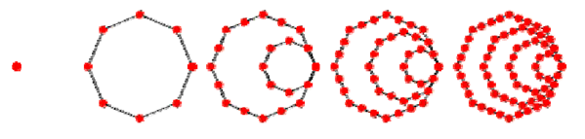

Consider the table shown below.

|  |  |  |  |  |  |  |  |
| --- | --- | --- | --- | --- | --- | --- | --- |
| n | 1 | 2 | 3 | 4 | 5 | 6 | 7 |
| En | 1 | 8 | 21 | 40 | 65 |  |  |
| Sn | 1 | 9 | 30 | 70 | 135 |  |  |

(a) Determine a rule for the nth Octagonal number (En).

[1 mark]

(b) Describe how the numbers in the Sn row are found and then determine a rule, in terms of n, for Sn.

[2 marks]

(c) Complete the missing entries in the table.

[2 marks]

(d) Find S50

[1 marks]

(f) Which is the smallest value for n for the sum of the Octagonal numbers Sn to first exceed 1 million?

[2 mark]

**Part Four: [8 marks]**

The Fibonacci sequence begins as follows 1, 1, 2, 3, 5, 8, 13, 21, . . .

Ebonie defines this sequence recursively by the rule Fn = Fn−1 + Fn−2 , F1 = F2 = 1

(a) Use the Recursive tab in ***Sequence*** to enter this rule and complete the table below.

|  |  |  |  |  |
| --- | --- | --- | --- | --- |
| n | 37 | 38 | 39 | 40 |
| Fn | 24 157 812 | 39 088 169 |  |  |

[2 marks]

(b) The table below lists the first seven Fibonacci numbers and some values in a new sequence. This new sequence Tn is defined as

Tn = 3Fn + 2Fn−1 for n ≥ 2

|  |  |  |  |  |  |  |  |
| --- | --- | --- | --- | --- | --- | --- | --- |
| n | 1 | 2 | 3 | 4 | 5 | 6 | 7 |
| Fn | 1 | 1 | 2 | 3 | 5 | 8 | 13 |
| Tn | dne | 5 | 8 | 13 |  |  |  |

Complete the table above.

[2 marks]

(c) You can write appropriate formula in ***Spreadsheet*** on the calculator to determine numbers in the sequences Fn and Tn.

Use ***Spreadsheet*** on the calculator to help you complete the table below.

[2 marks]

|  |  |  |  |  |
| --- | --- | --- | --- | --- |
| n | 37 | 38 | 39 | 40 |
| Fn | 24 157 812 | 39 088 169 | 63 245 986 | 102 334 155 |
| Tn |  | 165 580 141 | 267 914 296 |  |

(d) Phoebe makes a conjecture that Tn = Fn+3 for n ≥ 2

Test this conjecture for n = 37 and state whether it is true or false.

Show working and conclusion below.

[2 marks]

**Part Five: [10 marks]**

Tariro borrows $40 000 to buy a car and is required to make repayments of $670 per month. The first three months of his loan details are shown below. Some amounts are missing.

|  |  |  |  |  |
| --- | --- | --- | --- | --- |
| Month | Amount owing | Interest | Payment | Balance |
| 1 | $40 000.00 | $600.00 | $670.00 |  |
| 2 |  | $598.95 | $670.00 | $39 858.95 |
| 3 | $39 858.95 |  | $670.00 |  |

(a) (i) Calculate the monthly interest rate that Tariro is paying?

(ii) What is the annual interest rate that Tariro is paying?

[2 marks]

(b) Complete the missing entries in the table above.

[2 marks]

*Nic makes the claim “He will have the loan paid off in less than 12 years”*

(c) Check on Nic’s statement. Is it correct? Explain your answer fully.

[2 marks]

(d) Tanisha has found that just before the last payment Tariro owed $471.05. Determine the amount of the last payment that must be made in order to reduce the loan to zero.

[1 mark]

(e) Calculate the total interest that Tariro has to pay over the life of the loan.

[3 marks]

**Part Six: [4 marks]**

The parents of a newborn, Harmony, are financially astute. They placed $780 in an account when she was born and then continue to deposit another $780 on her birthday until she turns 18. The account earns 4.85% p.a. compounding yearly.

(a) How much will be in Harmony’s account on her 18th birthday? Describe/explain how you did this and what expression(s) you used on the calculator.

[2 marks]

(b) If instead of 4.85% p.a. Harmony’s parents could have found an account paying 5.25%, how much more money would she have by her 18th birthday? Show clearly how you found this answer.

[2 marks]

**Part Seven: [6 marks]**

To help banks and customers calculate repayments for different loans there is a formula. It is shown below.

Number of regular repayment needed



Interest rate per

payment period

Amount borrowed

Regular repayment

Indicate clearly how you solved each of these questions.

(a) Find the regular monthly repayment needed to pay off a car loan of $25 000 in seven years at an interest rate of 9.5% p.a.

[2 marks]

(b) A teacher borrows $15 000 to go to a Maths conference in the USA. The interest rate is initially 6% p.a. and regular repayments of $550 per month are made (with the exception of the last payment). The teacher is told the repayment time in months.

At the end of the 14th month, the lender informs the teacher that the annual rate of interest has increased to 12.75% p.a. Determine the new monthly repayment required in order to pay off the loan in the same amount of time.

[4 marks]

**THE END**